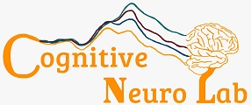

Cognitive Neurophysiology Laboratory

Rochester & Einstein

EEG Lab Manual

Primary Investigators:

John Foxe, Edward Freedman and Sophie Molholm

 

Table of Contents

A Message from the Technicians 4

Important Note! 4

Keywords 5

1. Preparation 8

1. Gather all supplies 8

2. Collect all necessary paperwork and documentation 9

3. Set up computers 10

4. Prepare the booth 10

2. Setting up the Participant 11

5. Fill out consent and paperwork 11

6. Screen for hearing and vision 12

7. Measure participants head 12

8. Attach externals 13

9. Place cap on participant 14

10. Apply gel 15

11. Connect electrodes to cap 16

12. Wrap cables to reduce kinks and tangles 16

3. Finalizing Setup in the Booth 17

13. Tape Bundle to Participant 17

14. Plug cables into amplifier box 17

15. Setting up EyeLink 1000 eye tracker 17

4. Checking Signal and Troubleshooting 18

16. Start Actiview to visualize signal 18

17. Check settings to confirm problematic electrodes 19

18. Identify electrodes to be regeled 19

19. Regel all necessary electrodes 20

5. Running the Experiment 20

20. Provide any additional equipment 20

21. Remind participant of instructions 20

22. Begin recording and start task 21

23. Monitor experiment 21

24. Offer breaks 22

25. Notes to take during experiment 22

6. Ending Experiment and Debrief with Participant 23

26. Stop data recording 23

27. Unplug all cables from amplifier 23

28. Remove all equipment from participant 23

29. Debrief with participant 24

7. Cleaning Up 24

30. Return all equipment to proper locations 24

31. Clean electrodes 24

32. Wash cap 25

33. Wash Gel Syringes 26

34. Lay equipment to dry 26

35. Clean booth and setup area 26

Appendices 27

1. Booth Setup 27

2. External Placements 29

3. EEG Signal 30

Signal Troubleshooting for Setup 30

Different EEG Signals While Recording 36

4. EyeLink Eye tracker 38

Displaying the camera on the participant’s screen 38

Setup 39

Calibrating steps 40

Trouble shooting during Calibration 40

Trouble shooting during experiment 43

General Eye link troubleshooting 43

5. File Structure and Naming Conventions 45

6. Hearing and Vision Testing 46

Hearing test 46

Farsightedness Vision Test 47

Nearsightedness Vision Test 48

7. Measuring stimuli sound with audiometer 49

Measuring speaker volume 49

Measure headphones of volume button-less devices 49

8. Rochester vs Einstein Protocol Differences 51

# A Message from the Technicians

This manual is intended to be used as a tool to help improve technique, reduce errors, and minimize artifacts as a way to improve the quality of data collected in the lab. It serves as a fundamental training tool for new lab members but can also be a handy reference guide for our “old pros” as well.

## Important Note!

Please be sure to bring the EEG booth back to its **original setup** after running any experiment. This is especially important if you have moved or disconnected any equipment inside the booth or brought additional supplies into the booth. This should **always** be done to ensure the next person using the booth is able to setup and run their experiment as expected and without delay. For details on the proper setup for each booth, please refer to the **Booth Setup Appendix** at the end of this manual.

Any differences in protocol within this document between the Rochester and Einstein lab procedures are marked with an * in the manual and fully detailed in the **Protocol Differences Appendix**.

# Keywords

*These are some common terms you may encounter throughout the manual, arranged here in alphabetical order.*

**Actiview**

* EEG data acquisition software created by Biosemi (see “Biosemi”).

**Acquisition Computer**

* A computer which receives, displays, and saves EEG data in real time (see “EEG”).

**Amplifier**

* Part of the EEG data acquisition system which is responsible for amplifying and converting analog EEG signal from the electrodes (see “Electrode”) into a digital signal which is sent to the acquisition computer.
* Electrode ribbons are directly plugged into the amplifier (See “Electrode Ribbon”).

**Assent**

* An IRB form describing study procedures in lay terms which is intended for research participants under 18 years of age (see “IRB”).
* This form needs to be signed by the participant but does not constitute full consent.
  + Also required is parental consent (see “Consent”), an IRB form which should be signed by the participant’s parent or legal guardian
* If your participant is over 18, this form does not apply to you.
* This form must be approved by the IRB and contain an up-to-date IRB watermark.

**BDF**

* EEG data output file format. Stands for “Biosemi Data Format” (see “Biosemi”).

**Biosemi**

* Manufacturer of the EEG equipment used at CNL (see “Amplifier,” “Actiview,” “BDF”).

**Cap / “EEG Cap”**

* Looks like a swim cap with equally spaced holes.
* Used to assist with electrode placement (see “Electrode”).

**CMS**

* This is the default reference electrode used by Biosemi (see “Reference”).
* Stands for Common Mode Sense.

**CNL**

* Acronym for the Cognitive Neurophysiology Laboratory.

**Config File**

* Configuration file ending in .cfg necessary for formatting EEG settings, for example: electrode labels and number of channels, in Actiview (see “Actiview”).

**Consent**

* Describes study procedures in lay terms intended for an adult reader.
* Must be signed by an adult over 18 years of age for every study.
  + If your participant is under 18, this form must be signed by the participant’s parent or legal guardian.
  + If your participant is over 18, they themselves must sign this form.
* This form must be approved by the IRB and contain an up-to-date IRB watermark.

**DRL**

* Stands for Driven Right Leg. Ground electrode for Biosemi systems (see “Biosemi”).

**EDF**

* A common output file format for eye tracking data and EEG data from non-Biosemi systems (see “Biosemi”).

**EEG**

* Stands for “electroencephalography.”
* A scientific and clinical technique used to detect electrical activity in the brain by measuring voltage changes at the scalp.

**Electrode**

* Small metal discs connected by thin, plastic wires to a larger bundle of similar metal discs (see “Electrode Ribbon”).
* These are sensors that detect electrical activity from the scalp resulting from neuronal activity.

**Electrode Ribbon**

* A single cable containing 32 electrodes (see “Electrode”).
* Electrodes on the cable are connected the cap and the bottom connector on the cable is plugged into the corresponding slot on the amplifier (see “Amplifier”).

**Externals**

* Shorthand word for “external electrodes.”
* These are electrodes attached to the participant using stickers which are not part of the electrode cap (see “Cap”).

**Host PC**

* The name of the Computer that does the eye tracking

**IRB**

* The ethics board for human research.
* All research studies must be approved by this board prior to data collection.
* All consent and assent forms must have a watermark indicating approval.

**Log File**

* Output text file from Presentation showing timestamps for experimental events and participant responses.

**MoBI (Mobile Brain Body Imaging)**

* Motion tracking system that can be used in conjunction with EEG data collection to allow for experiments that involve walking or other motion.

**Noise**

* Electrical activity measured by electrodes which is not attributed to brain activity.

**Offset**

* A running average of voltages measured between each electrode and the CMS.
* This is a measure of electrical noise (see “Noise”).
  + The closer this value is to 0, the better.

**Presentation**

* A stimulus delivery and experimental control program used at CNL.
* This is the software used to code most experimental tasks at CNL.
* Manufactured by a software company called Neurobehavioral Systems.

**ReadMe File**

* General naming convention for a text file containing experimenter notes.
* The more organized and well thought-out your ReadMe file, the easier your analysis will be.

**Reference**

* An electrode which has a stable and well-known electrical potential.
* The default reference in Biosemi systems is CMS (see “CMS,” “Biosemi”).
* All electrode voltages are displayed in Actiview with respect to the reference (see “Electrode,” “Actiview,” “CMS”).
  + This be changed from the default in Actiview or in analysis (see “Actiview”).

**Trigger**

* An electrical pulse sent from the computer running the experiment at the same time as an experimental event (see “Presentation”).
  + Experimental events can be stimulus presentations (e.g. a sound or a picture), or a participant response (e.g. button press, eye movements).
* This allows us to event-lock task events with EEG data.

# Preparation

You should arrive to the lab at least 30-45 minutes before your participant is scheduled to arrive in order to allow enough time for setup. This ensures you have enough time should you run into unexpected issues during prep or if your participant arrives early.

### Gather all supplies

Required supplies

Tape measure

EEG cap (a few sizes based on age)

Chin straps/gauze

Electrodes (channels, CMS/DRL, externals)

Alcohol wipes

Electrode gel

External stickers

Tape

Gel syringes

Amplifier battery

Disinfecting wipes

Optional supplies

Toys/Games

DVD player & DVDs

Chinrest

Keyboard

Response box/device

Game controller

Headphones

Eye tracker

1. **Collect all supplies needed for your experiment**
   1. Place electrodes flat on a table near where participant will be setup. Be sure to separate, detangle, and organize all cables ahead of time for easier use.
   2. Prepare age-appropriate things for participant to do during setup. Toys or movie for children, magazine or newspaper for adults, etc.
2. **Get a battery**
   1. Remove battery from charger and plug next battery in to ensure there is a fully charged battery for the next person.
3. **Fill gel syringes**
   1. Quantity of syringes needed will depend on number of channels being collected and number of individuals helping with setup.
   2. When filling, avoid creating air bubbles as best as possible. Syringes can be stood on end to release any accidental bubbles if done early enough.

### Collect all necessary paperwork and documentation

1. **Gather consent documents and ensure you have the proper version**
   1. Consent form for the appropriate protocol with IRB watermark
   2. Assent form as well if applicable (participant under 18)
2. **Be sure you have all additional paperwork before participant arrives**
   1. Participant Folder (this cannot be left unattended!)
      1. Checklist stapled into the front
   2. Run sheet for the appropriate protocol
   3. Medication sheet (ALSO FOR CONTROLS)
   4. Lunch menu if experiment is lengthy
   5. Parking pass (for participants who drive to the lab)

### Set up computers

1. **Turn on and sign into all needed computers**
   1. Presentation and acquisition computers.
      1. Be sure to load proper Config file in Actiview.
   2. Eye tracking computer, if using.
   3. For MoBI, set up computer for camera data acquisition.
2. **Create all needed folders for data collection, readme, and log files**
   1. For specific naming conventions, see **File Structure and Naming Conventions appendix**.
3. **Test all stimuli**
   1. Be sure audio and visual stimuli are occurring as expected.

### Prepare the booth

1. **Add all necessary equipment to the booth**
   1. Setup any additional equipment being used (mouse/keyboard/chinrest etc.). Check response buttons, eye or motion tracking, etc.
2. **Measure location of the monitor**
   1. Check distance of screen to chair or chinrest, from each wall to ensure it is centered, as well as to the back wall to ensure there is no tilt.
      1. This is important as some studies plug things in/out of the monitor and the position can be easily altered between experiments.
3. **Test volume if using auditory stimuli**
   1. Fully prep the booth before testing sound as you want to measure the sound exactly the way the participant will hear it. Objects/door open/placement of speaker/placement of screen/height of chinrest all impact the measurement.
   2. For full auditory testing protocol, see**audiometer appendix.**
   3. If you use **more than one auditory paradigm**, you will have to retest sound just before running that experiment.
      1. Be sure to ask participant to leave booth while retesting.

# Setting up the Participant

Ask participant if they want to watch a DVD, play a game or read during setup. Especially with young kids, this is in an effort to keep them entertained and so that they aren’t already bored before the EEG.

**Make sure hair is dry, loose and free of products!** If products were used that can affect the quality of the data (confirm with research technician/researcher) the participant should be asked to wash and dry their hair prior to setup. Make-up might also be a problem (foundation on the forehead is a problem for the frontal channels – please remove thoroughly with alcohol swab; mascara might be a problem when collecting eye data).

Make sure to **tell the participant that they cannot touch the cap**. When you are dealing with kids especially, tell them to let you know when it’s itchy so that you can help “scratch”. Don’t be afraid to be strict, moving the cap after gel is added can ruin an experiment!

### Fill out consent and paperwork

1. **Fully explain consent forms and sign**
   1. Be sure participant signs full name and properly dates.
   2. Ensure you sign and date all copies as well.
2. **Update medication sheet and get lunch order** 
   1. Usually only offer lunch for longer experiments.

### Screen for hearing and vision

1. **Depending on experiment, hearing and/or vision should be tested for all participants.**
   1. See **Hearing and Vision Test Appendix** for details.

### Measure participants head

1. **Use tape measure to measure circumference of participant’s head** 
   1. Measurement should be around the widest part of the head, parallel to the floor with tape measure snugly against the head.
   2. Select cap size based on this measurement, if measurement is between sizes use cap in best condition.
   3. All measurements should be collected and recorded in centimeters.
2. **Measure across top of head from nasion to inion** (see diagram below for locations)
   * Nasion: lowest part on the bridge of the nose, between the eyes
   * Inion: outward protrusion at the back of the head, can be felt with thumb
   1. 10% of this measurement is used to find placement for Fpz electrode.
   2. Use marker to indicate 10% location on forehead for proper cap alignment later.
   3. 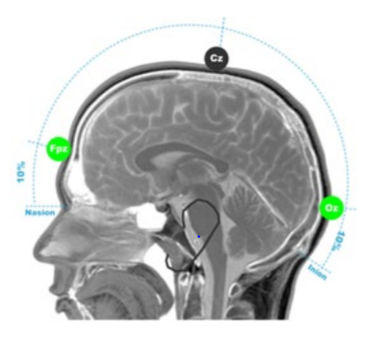
3. **Place selected cap on participant’s head**
   1. Align Fpz (translation for different number of channels in chart below) with forehead mark and ensure cap is on straight.
      1. The tag goes in the back.
   2. This is a rough check to ensure proper size was selected. The cap should not be so tight that it is stretching the fabric or so loose that the fabric bunches in between electrodes.
4. **The following chart is used to translate channel names based on cap being used**

|  |  |  |  |  |
| --- | --- | --- | --- | --- |
| **64 Channels** | **64 Channels** | **128 Channels** | **160 Channels** | **256 Channels** |
| **Fpz** | **B1** | **C17** | **D8** | **D8** |
| **Iz** | **A26** | **A25** | **A25** | **A16** |
| **Cz** | **B16** | **A1** | **A1** | **A1** |

### Attach externals

1. **Locate all placement points for externals based on protocol run sheet**
   1. Detailed information and locations are available in the **External Placements appendix.**
   2. Example locations:

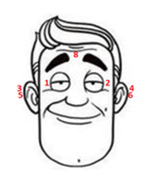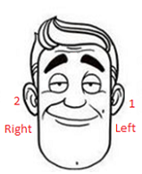

1. **Use alcohol swabs to thoroughly clean anywhere externals will be placed**
   1. This helps ensure good signal and that the externals stay in place.
2. **Attach external stickers to each external electrode**
   1. Hole in sticker should be placed around metal contact point.
3. **Place a moderate sized bead of electrode gel on the electrode head**
   1. Do your best to not scratch metal contact point with the syringe.
4. **Stick external electrodes on participant**
   1. Cables should point toward back of head. This avoids any possible bends or kinks in the wires that can affect data quality and longevity of the equipment.
   2. Facial external wires can be looped over the participant’s ears.
   3. Add small piece of skin tape to secure electrode if necessary.
   4. Any externals that will go over the cap can be placed later.

### Place cap on participant

1. **Attach chin straps/gauze to cap**
   1. Typical straps should be used for participants, when possible, especially controls.
      1. Ensure rougher Velcro side faces away from participant.
   2. If participant is uncomfortable, has sensory concerns, or the chin strap is too tight, gauze can be used.
      1. Be sure to tie tight enough to hold cap securely in place.
2. **Put cap on participant**
   1. If participant has hair in any kind of ponytail or braid, ask them to undo this if possible. Try to get hair to lay as flat as possible without too much hair in any one spot.
      1. Be sure not to push all hair to the back of the head. Do your best to evenly part and distribute hair so it does not cover ears or bunch together in one spot. This is particularly problematic if the hair bunches in the back as it can make the CMS/DRL connection more difficult.
      2. Some hairstyles may not be easily undone and some hair types (very thick, curly, etc.) may make EEG signal very difficult to collect. Refer to protocol or check with PI/study lead if unsure how to proceed.
   2. Use hands to hold cap open and slide gently onto participant’s head.
3. **Adjust cap so it is placed properly**
   1. To move or adjust the cap, use two hands to gently push and slide the cap. Do not pull or tug on the cap as this can easily stretch out the fabric.
   2. Ensure Fpz is lined up with 10% mark on forehead.
   3. Check that cap is centered and straight and that all electrodes are lying flat.
   4. In the back, Iz (64ch) should be located on the inion.
   5. In the front, Fpz (64ch) should be directly above nasion at level with 10% mark.
   6. On the top, Cz (64ch) should be centered and 50% between nasion and inion.
   7. Use tape measure to check!
   8. The tag in the back of the cap should be pulled out and visible once cap is in place. Leaving the tag inside the cap can occlude the electrodes and disrupt signal.
4. **Connect the straps/gauze**
   1. These should be snug under the chin to hold the cap in place.
   2. Make sure it is comfortable for the participant before moving on.

### Apply gel

1. **Ensure participant is comfortable and prepared**
   1. Before beginning to add gel, ask participant if they need to use the restroom. Bathroom breaks are less problematic before gel and electrodes are added.
   2. If the participant wears glasses, this is the moment to make sure the glasses are on comfortably since the **participant should not take their glasses off/on during the EEG or break**. If they need to take them off, do it for them to reduce chances of getting caught in wires or moving the cap.
2. **Add gel to cap systematically**
   1. Carefully move the syringe in a circular motion to push hair aside and ensure the gel makes contact with the scalp. Then slowly pull syringe while dispensing gel to create a channel of gel from scalp to electrode.
      1. Participants with thick or a lot of hair may take extra time to really ensure the column is reaching the scalp fully.
   2. Check that participant can feel gel on their scalp (it should feel cool) but that the process did not hurt.
      1. If they express discomfort, you may be pressing too hard or scraping their scalp so try more gently and check in again.
   3. Once you have started adding gel, it is very important that the cap DOES NOT move!
      1. If the cap moves after gel is added, it is very likely to cause bridging and often will result in ending the experimental session.
      2. Be sure not to push on cap while gelling as this can move the cap or electrode holders that already have gel in them.
   4. When applying gel by yourself, fill in order to ensure none are missed.
   5. If more than one person applying gel, avoid splitting the process by left and right.
      1. This can cause artificial hemispheric differences in signal. To avoid this, either have on person do the sides and another do the middle, or split the task by front and back instead.

### Connect electrodes to cap

1. **Gather all ribbons cables needed**
   1. Drape the cables around your neck to reduce tension and tangling.
2. **Plug electrodes into corresponding holders**
   1. Be sure to hold electrodes by the plastic housing, not the wire.
   2. Plug electrodes into the proper holder, working from back to front to reduce tangling and overlapping wires as best as possible.
   3. It is helpful to point wires toward back of head to avoid kinks and keep wires out of the participant’s face.

### Wrap cables to reduce kinks and tangles

1. **Bundle all cables together**
   1. Lay all ribbon cables flat together. External cables can be tucked between two ribbon cables to keep them contained.
2. **Use CMS/DRL to wrap bundle**
   1. Gently wrap CMS/DRL around the bundle to hold it all together. If needed, you can use tape to help keep everything neat and together.
   2. Ensure there is plenty of slack for CMS/DRL at the top and that the bundle is not pulling on the cap.

# Finalizing Setup in the Booth

### Tape Bundle to Participant

1. **Tape bundle to participant**
   1. Make sure participant isn’t wearing a jacket they plan to remove.
   2. Use tape to attach the bundle to the participant’s shoulder. This ensures there is slack in the cables as they connect to the cap and reduces pulling on the wires.

### Plug cables into amplifier box

1. **Connect and turn on battery**
   1. Connect the battery to the amplifier and be sure it is turned on.
2. **Plug in CMS/DRL first**
   1. Once this is connected, the blue light on the amplifier should turn solid blue.
   2. Monitor the blue light as you connect the rest of the electrodes to identify any damaged/faulty cables. The blue light will blink if there is a problem with a cable.
3. **Plug in the remaining cables**
   1. Use two hands to connect ribbon cables with the ribbons facing the top of the AD box, ensuring you plug them in evenly without bending/damaging pins.
   2. Plug in all external cables.
   3. Be sure to monitor blue light on AD box after each cable you insert.
      1. If it starts blinking, check that the last cable is inserted fully. Otherwise, you will need to replace the cable and mark the first one for testing/repair.

### Setting up EyeLink 1000 eye tracker

1. Display the eye tracking camera on the participant’s display.
   1. This allows you to see on the screen how you need to position the camera without going out of the booth to check the host PC. It is also a great way to distract kids if they have to wait for a moment before the EEG begins.
   2. See **EyeLink Eyetracker appendix** for how to do this, including how to do this if you already started your paradigm.
2. Place the black and white circular sticker on either the forehead of cheek of the participant.

*This allows more head movements without the eye tracker losing the eye. Not having the sticker prevents not only eye tracking in general, but also stops the eye tracker from assigning decent auto-thresholds for pupil and CR.*

* 1. If you see red lines around the sticker or eye on the Host PC, plus a warning box turning read saying “NEAR EYE” you need to move the sticker up or down away from the eye.
  2. If you see a red warning box saying “BIG ANGLE” you need to move the sticker more to the center of the participant’s face. The camera is detecting too much of an angle of the sticker.
  3. See **EyeLink Eyetracker appendix** for more info

1. Set up the eye to be tracked

*This should only be a labeling issue according to the eyelink manual. However, it seems to impact calibration when switching eyes.*

* 1. At the bottom on the screen on the host PC, click on left or right (depending on what eye you are going to track).
  2. Click on the corresponding eye of the participant.

1. Complete optional first calibration, if desired.
   1. You can potentially calibrate before you start the paradigm. You should re-calibrate once you start the paradigm using presentation.
   2. See the **Eyelink Eyetracking appendix** for more info

# Checking Signal and Troubleshooting

### Start Actiview to visualize signal

1. **Click ‘Start’ in upper corner to view signal**
   1. This will begin data visualization on the screen.
2. **Check signal on ‘Monopolar’ tab**
   1. Be sure to look at signal from all ribbon cables using drop down menu.
   2. They should all show activity but all look relatively similar.
3. **Check offsets on ‘Offsets’ tab**
   1. Change scale to 50mV on the left.
   2. Offsets should be no more extreme than +/- 40mV, but between +/- 20mV is ideal.
      1. The closer these are to 0 mV and the more uniform across all electrodes, the better.

### Check settings to confirm problematic electrodes

1. **Check average reference to confirm signal that looks flat**
   1. If electrodes are very close to CMS/DRL they may appear flat using the default reference, but changing to average will identify if signal is truly flat or not.
2. **Check filters to identify source of noise**
   1. Low pass 50 Hz filter will remove any electrical noise from the visualization on the Actiview screen.
      1. Be sure participant does not have phone in booth if this is the case.
   2. High pass 1 Hz filter should correct drift.
3. **Reset everything to default**

### Identify electrodes to be regeled

1. **Select electrodes to troubleshoot**
   1. Any flat or noisy electrodes not corrected by steps above should be checked.
   2. Any electrodes with offsets outside of desired range or significantly different than the rest should be checked as well.
   3. Electrodes with unstable offsets should also be regeled.
   4. If all channels are noisy or offsets fluctuate in unison, CMS/DRL should be regeled.
2. **Record which electrodes have been regeled**
   1. Be sure to write down and record in your files which electrodes you plan to check.

### Regel all necessary electrodes

1. **First check all identified electrodes**
   1. Before adding more gel, check that the electrode was fully connected. Sometimes electrodes are loose and look like they have bad signal, but just fully connecting them corrects the problem.
2. **Regel when needed**
   1. Remove electrode carefully, hold the plastic casing- do not pull from the wire, without moving the cap.
   2. Carefully add a little bit more gel to create a better channel. Only add a small amount of gel to avoid bridging to neighboring electrodes, especially when working near CMS/DRL.
3. **Recheck signal and repeat if needed**
   1. Be careful when regelling a second time as the risk of bridging increases every time you add more gel. It is not recommended to regel more than twice.
   2. If any electrodes cannot be recovered with regelling make a proper note.

# Running the Experiment

There should always be someone monitoring the computers and the participant throughout the entire experiment. Be sure you schedule your time properly or ask for help to cover any breaks, even something as short as running to the bathroom or to get water.

### Provide any additional equipment

1. **Provide response button or any other needed equipment**
   1. Make sure participant can reach and knows how to use everything.
2. **If using, place headphones**
   1. Place carefully without moving cap or disturbing electrodes.

### Remind participant of instructions

1. **Review task directions**
   1. Ensure participant understands the task and when breaks will be offered.
   2. Reinforce good work during training (if done) on the task to let them know you’re monitoring their responses. Can also remind of instructions if needed.
2. **Remind about general EEG instructions**
   1. Participant should not move, remove headphones or equipment, pull on wires, eat, or drink during recording.
   2. They should be seated with feet flat on the floor.
   3. Make sure they know how to communicate with you if needed.

### Begin recording and start task

1. **Finalize setup**
   1. Turn on intercom and camera. Explain how they work to participant and how you will be monitoring them during the experiment.
   2. Close booth door and/or turn lights on/off as specified in your protocol.
2. **Start recording**
   1. Create your save file and begin recording in Actiview.
3. **Begin task**
   1. Start task on Presentation computer.
   2. **If you are using an EyeLink 1000 eye tracker**, you need to click “calibrate” if it is the first block or if during the previous block the eye tracking failed / needed to be corrected for drift. It is recommended to calibrate 2x in a row at the start.
      1. See the **trouble shooting during calibration appendix** for more info.
   3. Once you are done with the Eye tracker calibration you need to click “Output Record” or the “O” button on the keyboard to start the paradigm.
   4. Make sure triggers are appearing properly in the Actiview data visualization screen on the ‘Monopolar’ tab.
      1. Also check participant response triggers if this is a part of your task to be sure they are appearing and that the pattern of responses indicate the participant seems to understand the task.

### Monitor experiment

1. **Monitor EEG signal**
   1. Watch for alpha waves, see **Signal Troubleshooting appendix** for example,
      1. This would indicate your participant is getting drowsy or has their eyes closed and may either need a verbal reminder or a break.
   2. Record any electrodes that become noisy during recording.
      1. Make note to check/regel during breaks when appropriate.
2. **Check in with participant regularly**
   1. Update your participant between blocks or if you notice motion during recording.
   2. Talk to participant if you notice alpha waves.

### Offer breaks

1. **Take breaks if needed**
   1. Be sure to pause recording on Actiview before taking break.
      1. Some tasks do this automatically, but you should visually confirm.
   2. For snack breaks, be sure participant has water before restarting to avoid chewing artifacts.
      1. For children, be sure to check with parent about food restrictions or allergies first.
   3. For bathroom or longer breaks (stretch legs, lunch, etc.) use a backpack to secure all cables.
      1. Carefully unplug all cables and place them in bag and help participant put on backpack without moving cap.
      2. Remind participant not to lean back on the cables.

### Notes to take during experiment

1. **Record all notes in appropriate places**
   1. Written notes can be taken on a run sheet but all notes should be recorded in a digital ReadMe file on the computer.
   2. This allows you to have access during analysis and for future use of the data.
2. **Take notes on signal and computer issues**
   1. Note electrodes that become noisy or problematic.
   2. Note if there are any errors with the code or while running the experiment, such as unexpected computer crashes.
   3. Note the quality of the eye tracking if you are using the eye tracker.
3. **Take notes on participant behavior**
   1. Note if participant tends to move a lot or has other artifacts during recording.
   2. Note if task performance is poor for any reason.
   3. Note if participant takes breaks or ends early, also note and explain this.
   4. Note, if you are using the eye tracker, if the participant’s gaze is in an odd position.

# Ending Experiment and Debrief with Participant

### Stop data recording

1. **Stop recording on Actiview**
   1. Take notes of offsets at end.

### Unplug all cables from amplifier

1. **Turn off battery and disconnect**
2. **Unplug all cables**
   1. Press both releases for ribbon cables at the same time to ensure cable comes out smoothly.
   2. Remove external cables and CMS/DRL at the connection point, do not pull wires.

### Remove all equipment from participant

1. **Remove cap**
   1. Undo chin strap or gauze.
   2. Carefully remove all electrodes from the cap before removing cap.
      1. Pull electrodes out from channel holding the plastic housing without pulling on the wire to avoid damage.
      2. Removing electrodes while the participant is still wearing the cap helps reduce damage and increase the longevity of equipment.
   3. Remove cap carefully to avoid pulling hair.
   4. Place all items in a bowl or gather together for transport and cleaning.
2. **Detach all externals**
   1. Carefully remove externals without pulling on wires.
      1. Alcohol wipes can be used to help loosen adhesive.
3. **Remove any other equipment**
   1. If any other equipment was used be sure to remove and collect it all.

### Debrief with participant

1. **Finish any experiment related procedures**
   1. This could include post-EEG surveys or other tasks.
   2. Allow participant to ask questions about the EEG.
2. **Allow participant to clean up**
   1. Show them where to wash hair, including shampoo and clean towels.
3. **Finalize compensation**
   1. Review amount and method of compensation.
   2. Have participant fill out and sign any paperwork needed.
4. **Walk participant out of the building**
   1. Be sure participant knows how to exit and has transportation.

# Cleaning Up

Proper clean-up is as crucial as set up for the overall success of data quality in the lab. Dirty caps or electrodes can greatly impact signal for the next experiment using them, so this step is not trivial and should be done with care.

### Return all equipment to proper locations

1. **Return booth to default setup (see** **Booth Setup appendix****)**
   1. This includes removing any additional items brought into the booth or any equipment that was moved or taken out of the booth during setup.
2. **Remove battery and plug into charger**
   1. Be sure light indicates battery is charging.
3. **Make sure to unplug all the electicity**
   1. Special mention for the EyeLink eye tracker, it might overheat if left on over-night and break.

### Clean electrodes

1. **Get water for cleaning**
   1. Collect warm water that is either filtered or deionized, NOT regular tap water, in a glass or plastic bowl, never allow electrodes to contact metal.
      1. Do not use tap water.
   2. Allow electrodes to soak in the warm water for a few minutes to loosen gel.
2. **Remove all gel from electrodes**
   1. Gently remove all gel from electrodes being careful to keep connector ends dry and away from the water.
   2. Do not use soap, if required use approved cleaning supplies from Cortech only.
      1. This includes hydrogen peroxide for the cables and soaking in alcohol for the electrodes.
      2. If you don’t know where these supplies are in your lab, ask a technician. Do not use soap.
   3. Start with your fingers to gently remove gel, touching the metal contact end as little as possible.
      1. For any particularly difficult to clean electrodes, a plastic toothbrush can be used to carefully dislodge the gel.

### Wash cap

1. **Remove chin strap or gauze**
2. **Soak the cap in soapy water**
   1. Place cap in bowl with warm water and shampoo for a few minutes.
3. **Wash cap and all electrode holders**
   1. Rinse soap from cap.
   2. Clean each holder systematically to ensure gel is removed from all holes.
   3. Use a small brush to clean each holder one by one.
      1. Be sure to rinse/wipe off brush between each holder to avoid transferring gel from one to the next.
   4. Give both sides of cap a final rinse and check for remaining gel.
4. **Towel dry cap**
   1. This removes some of the excess water weight and reduces stretching of the cap while drying.

### Wash Gel Syringes

1. **Return any unused gel to the bottle**
2. **Rinse syringes in the sink**
   1. Be sure to remove all gel from plunger, inside syringe, and especially ensure the tip of the syringe is clear of all gel.
   2. Use soap to sanitize the syringe tip. Can also use an alcohol wipe if desired.
   3. Syringes should only be thrown away if gel is not able to be removed (i.e., dried up) or are broken/damaged in some way in order to reduce waste in the lab.

### Lay equipment to dry

1. **Place cap on head model, cap stand, or towel**
2. **Place syringe and plunger on drying stand**
3. **Lay all electrode cables out on towel**
   1. Keep all connectors away from damp electrode ends.
   2. Go through each ribbon cable to detangle and gently smooth any bends in the wires.

### Clean booth and setup area

1. **Wipe down surfaces**
   1. Wipe down all tables, chairs, and equipment the participant touched using disinfecting wipes.
   2. Be sure to fully clean up any gel residue.
2. **Remove trash and vacuum**
   1. Throw out all trash.
   2. Vacuum floor for dirt or snack debris.
3. **Turn off lights and power supply**

# Appendices

# Booth Setup

This contains all the standard equipment that should be the default state for each of the EEG booths in the lab. Booths should be returned to this state after every experiment.

**Einstein**

All booths:

* Table for screen
* Table for eye tracker
* Viewsonic vp2655Wb screen
* Webcam
* Intercom
* Speakers
* Chair
* Amplifier

*Kids booth Left / Adult booth Right extra:*

* *Eye tracker*
* *Chinrest*

MoBI:

* Treadmill
* Projector
* Amplifier
* 2 Chairs

**Rochester:**

Left Booth:

* 1 chair
* Keyboard
* Eye tracker
* 2 sound cancelling headphones
* Regular headphones
* Intercom system
* Doorbell
* Amplifier
* Monitor
* Webcam (pending)

Right Booth:

* 1 chair & 1 stool
* Motion tracking cameras
* Headphones
* Intercom system
* Doorbell
* Keyboard
* Game controller
* Amplifier
* Monitor
* Speakers
* Webcam (pending)

MoBI:

* Treadmill & harness system
* Motion tracking cameras
* Tall ladder
* Small ladder
* Projector and screen
* Tall chair
* Amplifier
* Battery and Charger
* Webcam (pending)

# External Placements

This contains a full list of external placements options and details on how to verify they are placed properly.

*Note: the numbers 1-11 are only used as a guide to the figure shown here, numbering and usage practices for externals is study specific and any questions on this should be directed to the study lead.*

1. **Horizontal Eye- right**

* Placed about 1cm to the outside of the eye, aligned to the center of the eye, on the bone. Is often helpful to point wire toward back of participant’s head.

1. **Horizontal Eye- left**

* See above.

1. **Mastoid- right**

* Placed on the mastoid bone behind the ear. To find the proper placement, feel behind the participant’s ear roughly horizontal from their tragus to find where the bone is thickest. Be sure to clear the spot of hair before placing the external.
* If you place this too high, you may pick up brain activity rather than null signal used for referencing and artifact detection.
* If you place this too low you will pick up the participant’s heartbeat leading to an EKG artifact from the carotid arteries.

4**.** **Mastoid- left**

* See above.

1. **Eyebrow**
   * Placed at the top of the bridge of the nose, directly between the eyebrows.
2. **Nose**

* Placed on the tip of the nose, being careful it is attached securely.

1. **Vertical** **Eye- up**

* Placed above the eyebrow, around 2cm above the eye and in line with the pupil.

1. **Vertical Eye- down**

* Placed below the eye, around 2cm below the eye on the cheekbone and in line with the pupil.

1. **Earlobes**

* Placed on the bottom of the participant’s ear, being sure it is securely attached and all nearby earrings are removed if possible.

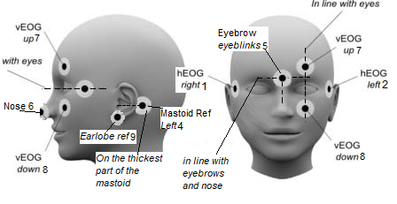

# EEG Signal

The following demonstrates and explains common issues seen with EEG signal. Use the bold headings or images to find the section that corresponds to the signal issue you are seeing.

## Signal Troubleshooting for Setup

1- Signal does not Resemble EEG Data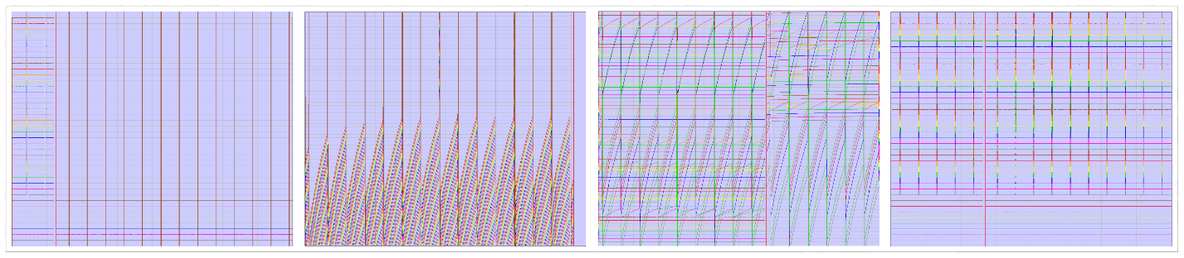

1. Likely a problem with CMS/DRL
   1. First, make sure CMS/DRL are plugged into the cap properly.
   2. Check the blue light on the amplifier box.
      1. If the light is blinking, either one of the cables (ribbon or external) is bad or the CMS/DRL are not making good contact.
      2. You can unplug cables one at a time to check if one is bad. When the bad cable is removed, the blue light should go back to solid.
      3. If a cable is bad, remove it, set it aside, and reconnect a new cable.
   3. If no cables are bad and the issue persists, carefully regel CMS/DRL.

2- High Frequency Noise in all Channels

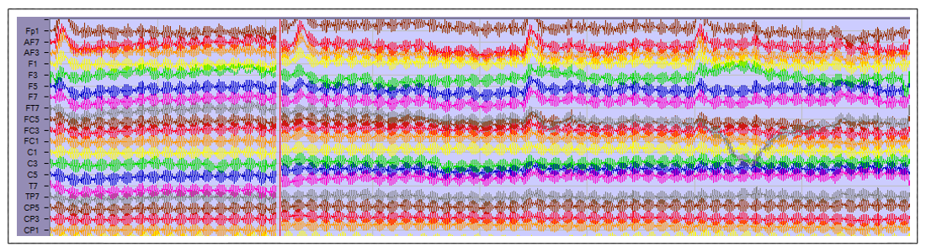

1. First, have the participant touch the wall/door of the booth to reduce any possible static electricity (especially in the winter).
2. Make sure the participant’s feet are touching the floor.
   1. If participant cannot reach the floor use a box or step stool to create a surface for their feet to rest on. This helps with the ground reference of the system.
3. Check the blue light on the amplifier box.
   1. If the light is blinking, either one of the cables (ribbon or external) is bad or the CMS/DRL are not making good contact.
   2. You can unplug cables one at a time to check if one is bad. When the bad cable is removed, the blue light should go back to solid.
   3. If a cable is bad, remove it, set it aside, and reconnect a new cable.
4. Regel either CMS or DRL very carefully with a small amount of additional gel.
   1. Check if it’s better. If not, regel the other one.

3- Offset Above or Below +/-30

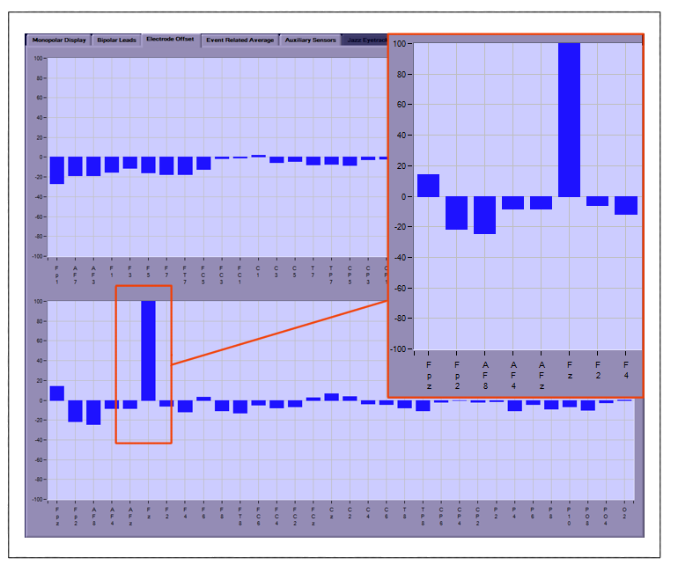

1. If just one or a select few channels have high offsets, simply regel those channels.
2. If it’s all the channels, there is likely some electrical interference.
   1. Ensure the participant’s phone is turned off.
   2. You can also move the amplifier to a new location or separate table.
   3. If this hasn’t helped, regel first CMS and then if still problematic regel DRL.
   4. You can also try regelling individual channels.
      1. If this helps it means all channels were likely undergelled.

4- High Frequency Noise in Channels above Ear

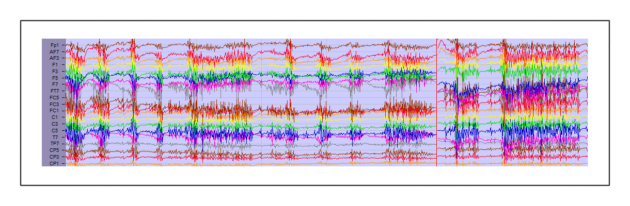

1. Likely chewing artifact. Make sure your participant isn’t:
   1. Eating or drinking in the booth.
   2. Biting on something (like their own tongue or lip).
   3. Pressing too strongly down on the chinrest.

**5- Bridging Multiple Channels**

1. This means the gel from 2 channels is connected under the cap so the signal collected from each channel is the same.
2. DO NOT regel, this will not improve your data and risks additional bridging

5.1- CMS to P1

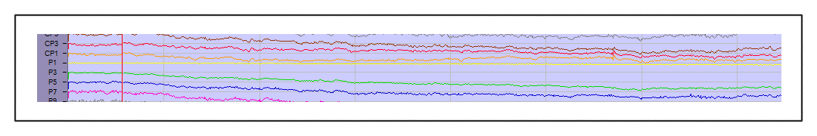

1. Will appear as P1 being totally flat. This is because CMS is the reference and when P1 is bridged it is essentially being referenced to itself.

5.2- DRL to P2

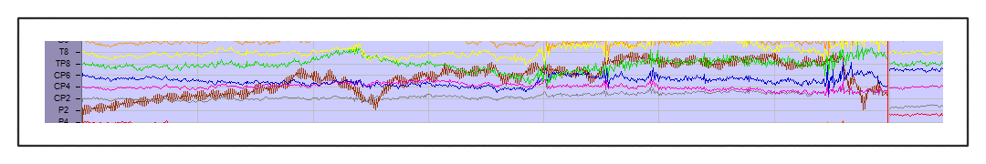

1. P2 appears noisy and won’t correct with regelling. This is because DRL is the ground and is now averaged with actual data.

5.3- C5 & T7

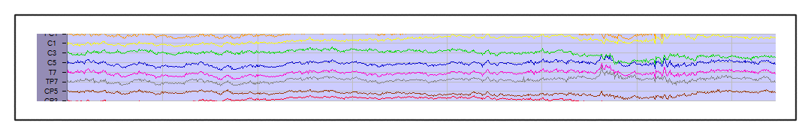

5.4- FZ & F2

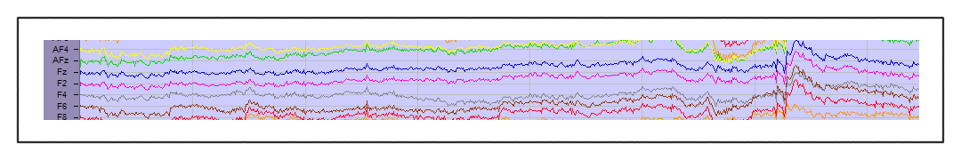

1. Hard to tell with individual channels, but they will look exactly or almost exactly identical and all motion/changes in the channels over time will be the same.

6- Channels have Low Frequency Drift

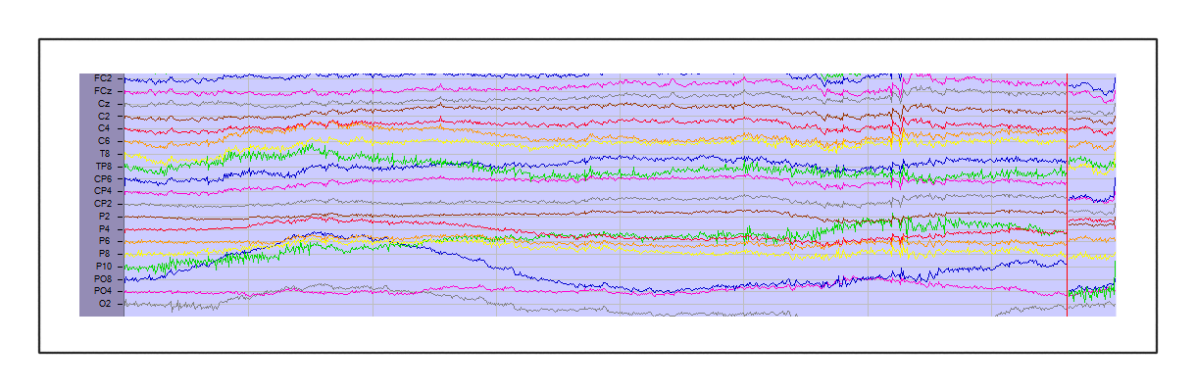

1. Ensure your participant is not too warm, sweating can cause this drift.
2. Regelling can help if the issue is not sweat related.

7- Frontal Channels have Extra Noise

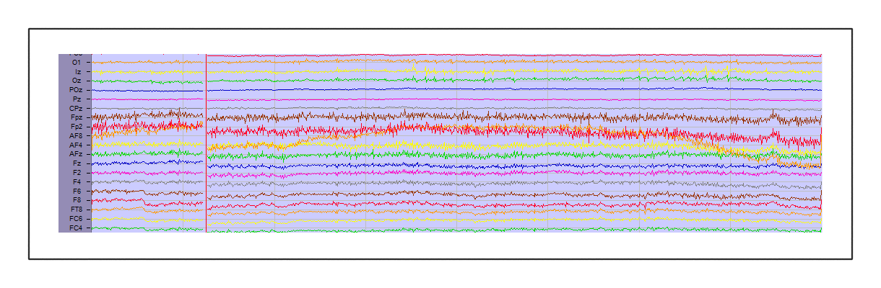

1. Check that participant is not squinting.
   1. This can add muscle activity around the face and forehead.
2. Check that chinrest is in a comfortable location and not too low to see screen.
   1. Raising their eyebrows can add muscle noise in the channels near the forehead.
   2. Eating or drinking in the booth.

8- Channel Appears Flat

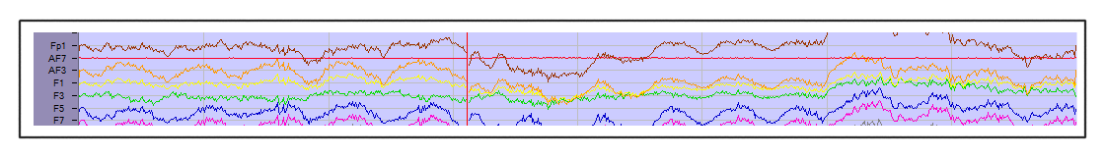

1. First adjust amplitude scale in ActiView to 5uV instead of 100uV to confirm if channel is truly flat or collecting low signal.
   1. If channel is truly flat, unplug electrode to check if channel was gelled.
      1. If not, add gel and check signal.
      2. If there is gel in the channel, the electrode is likely bad. Try a new electrode set and set aside the problematic one for further testing.
   2. If channel has low signal, try carefully regelling.

9- Noisy Channels

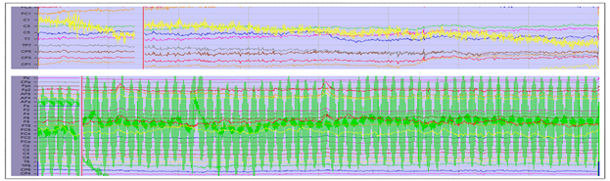

1. Regel affected channels, with extra emphasis on reaching the syringe all the way to the scalp to create a full column of gel.
   1. Add enough gel to create a column, but be careful to avoid overfilling as this can cause bridging to neighboring electrodes.
2. Depending on how much gel you add in the first regel you may be able to try once more if the problem is not solved.
   1. Every regel increases the chance of bridging and this is easier to do the higher number of channels in your cap- be careful!

10- Odd Signal in Frontal Channels

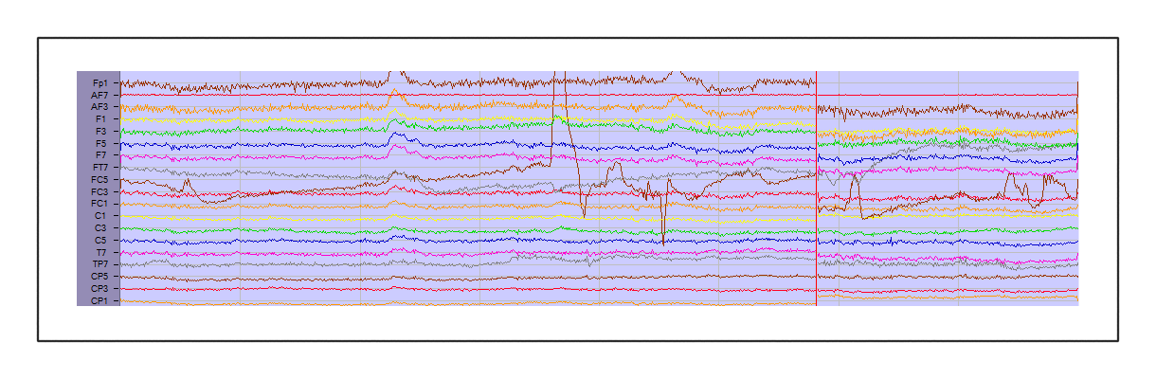

1. This is often caused by pressure or tension on the cables or cap. Check:
   1. That your participant is not touching the metal bars or the sides of the chinrest.
   2. Your participant is not leaning back with their head against the chair.
   3. There isn’t tension on the ribbon cables pulling on specific channels.

**11- Unstable Offsets**

1. Some might move up/down a bit, but in general they shouldn’t bounce around too much.
2. Check to see if the participant is moving around.
   * 1. Too much motion can cause the offsets to also move around a lot.
     2. If it isn’t motion related, regel the affected channels.
3. If all channels are unstable it is likely an issue with CMS/DRL connection.
   * 1. Carefully regel CMS and then DRL checking in between to see when stability improves.

**12- Blink Artifact after Every Visual Stimuli**

1. This could cause all the data to be rejected during analysis. Check in with participant to remind them it is important to not move too much during task.
   1. NOTE: telling someone “do not blink” might cause issues for some people
      1. Some people cannot control it
      2. Some people will stress their forehead so much that that becomes an issue
      3. Some people will get a headache very quick when they focus on this
      4. Some people might start blinking significantly more during other moments that are also important.
   2. Potential solution: tell the participant when you’d like them to blink rather than just stating they shouldn’t blink and also offer extra breaks if needed.

**13- Participant is not responding accurately**

1. Before addressing this be sure you know from the PI or study lead if response correctness is important.
   1. If they are, explain this to the participant.
2. Ensure participant understands the task and the instructions.
   1. If this doesn’t help, consider if person is truly capable of performing the task.

**14- Strong Noise after Mistakes**

1. Likely your participant is reacting to their mistake very strongly.
2. Explain to the participant that we are not expecting anyone to perform perfectly.
   1. Mistakes are also interesting and important to research and some tasks are designed so people can’t be perfect, explaining this can take some pressure off.

## **Different EEG Signals While Recording**

Brief overview of various types of signal that may be seen during an EEG recording session.

**Eyeblink**(1 “bump” = 1 eye blink)

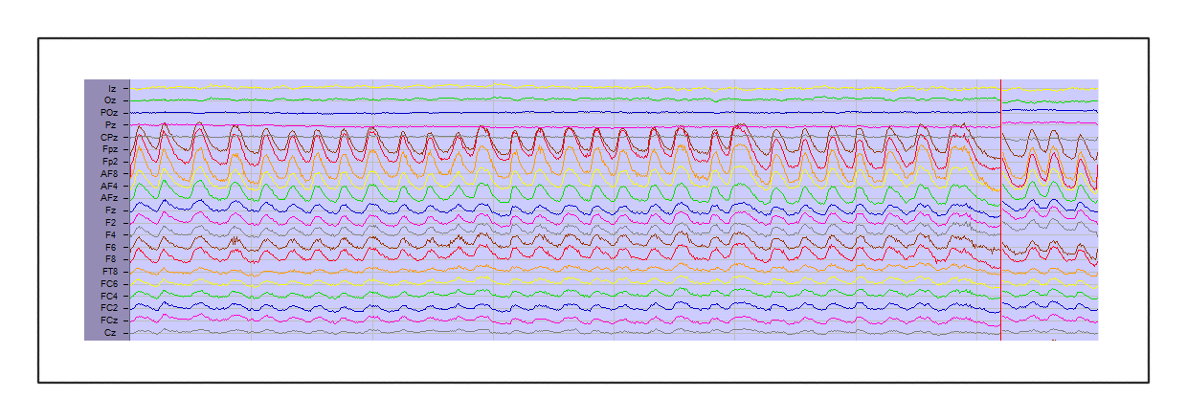

**Alpha**(lack of attention/participant is tired/participant has their eyes closed)

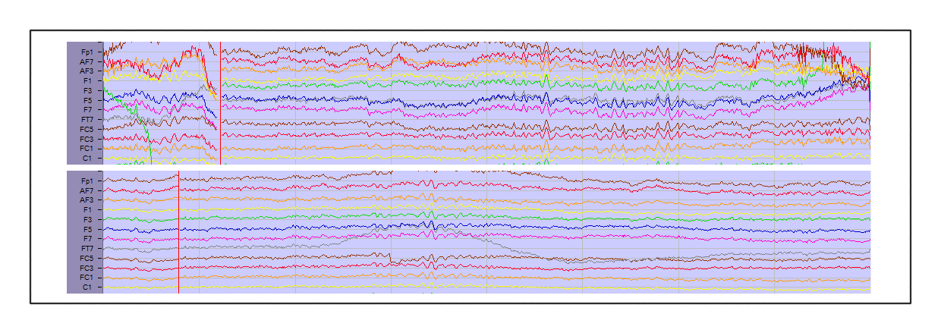

**Chewing**(muscle activity is stronger than brain activity, so it overpowers the signal)

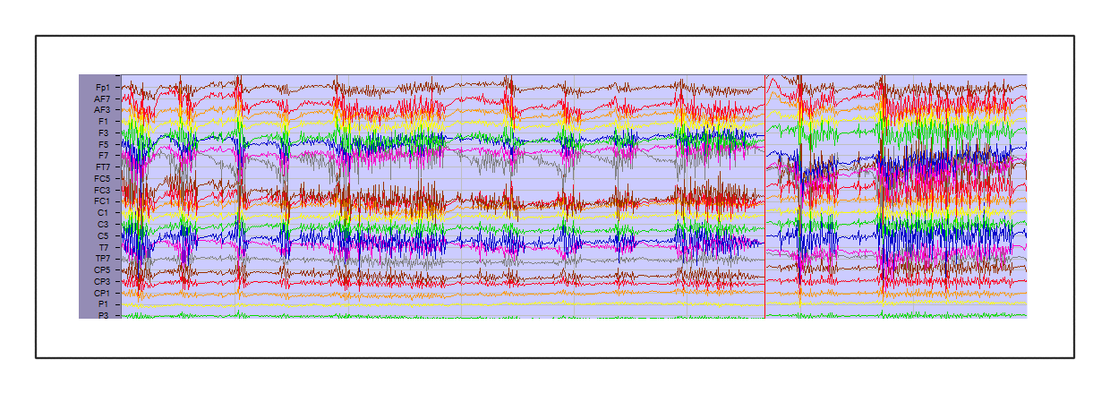

**Shaking head**/General Motion

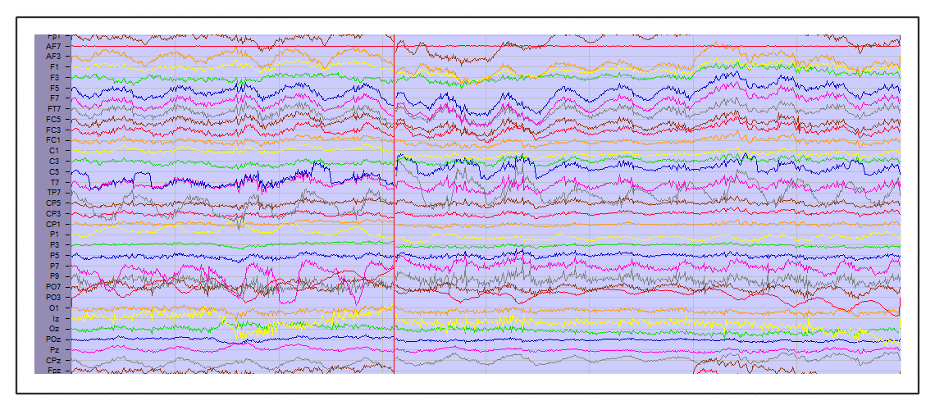

**Sweat**



**Losing contact**(could happen if a participant leans backwards and CMS/DRL lose the scalp)

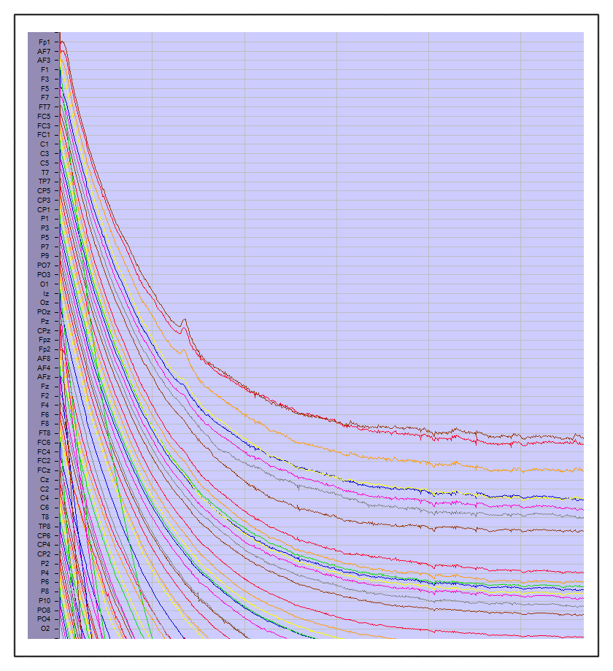

**Touching channel**(Fp1 is being touched)

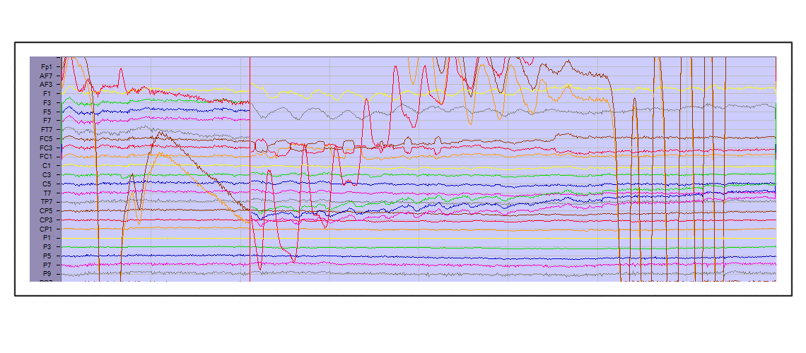

# EyeLink Eye tracker

This includes information on the why and how to do great eye tracking.

## Displaying the camera on the participant’s screen

If you open the eye icon 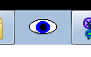 (picture.exe) you should see a gray screen. If you press enter once, one of the camera screens show up there. You can use the arrow keys of your keyboard to cycle through the different camera views (full camera, focused on eye, focused on target).

*If you are already running your paradigm and you want to do this before calibrating*, you can by clicking ‘transfer camera image’. After that, you can manipulate it the same way with the arrow keys.

Why? Because this allows you to change the angel of the camera while you can see instantly how the result looks, but more importantly, it allows you to focus the lens.

1. **Moving the camera** – grab it with both hands and while keeping the standard on the table you can move it around.
2. **Focusing the camera** – this is done by SLOWLY rotating the lens. This moves really easily and should never need force. If somehow it feels stuck, you either have your camera too far away /to close by and you, are at an extreme or you are twisting something else (like the aperture ring).

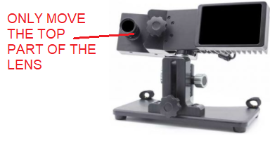

**DO NOT ROTATE THE BOTTOM PART** between the lens and the camera. **This ring controls the aperture**, so you will allow more or less light to enter the camera. This will significantly impact the data for this and future collections until it is put back correctly.

## Setup

1. **Distance (eyetracker to eye)** – the suggested range for the eyetracker to the eye 40-70cm (15.7- 27.6 inches)

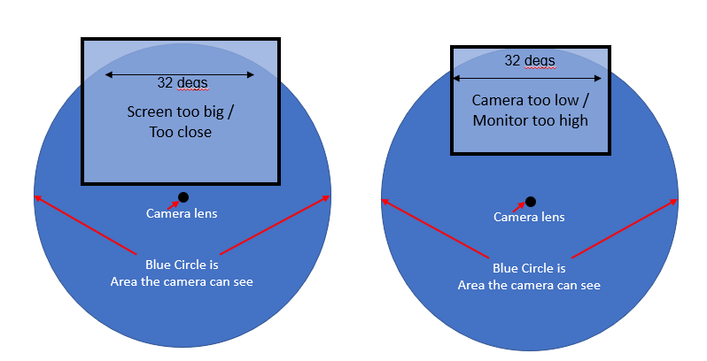

1. **Distance (eye to screen)** – this has to do with the width of the screen. The camera has a trackable range of 32 degrees horizontally by 25 degrees vertically. This means that the distance from the Participant’s eye to the monitor should be at least 1.75x the monitor width. For a 55cm wide screen, this results in a minimum of 96.25cm or 37.9 inches.
2. **Height (screen)** – the eyes of the participant should be at the height of the top 25% of the screen (highlighted in green in the figure below. Lower the screen or increase the height of the chinrest while keeping the participant comfortable. Keep in might that blocking speakers that might be behind the screen, impacts the volume for the participant.

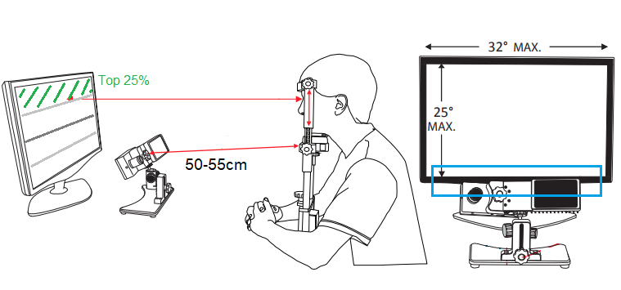

## Calibrating steps

1. Explain to the participant that they need to focus on the crosses they will see on the screen.
2. Press the ‘calibrate’ button.
3. Press space after you see that the gaze is stable on the first cross.
4. Wait for all the calibration points to automatically be accepted.
5. Click on ‘accept’ to accept calibration.
6. Click on ‘Validate’ to validate your calibration.

## Trouble shooting during Calibration

1. **The eye looks really blurry and/or the Eye link system doesn’t see the pupil/corneal**
   1. Focus the camera. See “display the camera on the participant’s screen” for more info.
2. **I clicked on “left”, in the box beneath the eye distance and thresholds, but I ended up recording the right eye**
   1. This doesn’t impact the data, it just labels it wrong. Write it down in the readme file so the person who will analyzes it is aware. Fix this during the next possible moment. (see figure below)

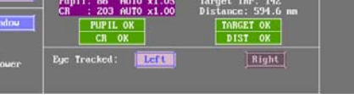

1. **Finding the right pupil threshold**
   1. Once you click on the eye it should calculate the recommended value instantly.
   2. If you decrease the pupil when calibrating (or even after calibrating) you should see the whole inside of the pupil turn dark blue. If you see black spots your pupil threshold is too low. If you see dark blue outside of the pupil in the eye or on the eyebrow you have a too high of pupil threshold. You need to manually increase/decrease it. This is done by clicking the 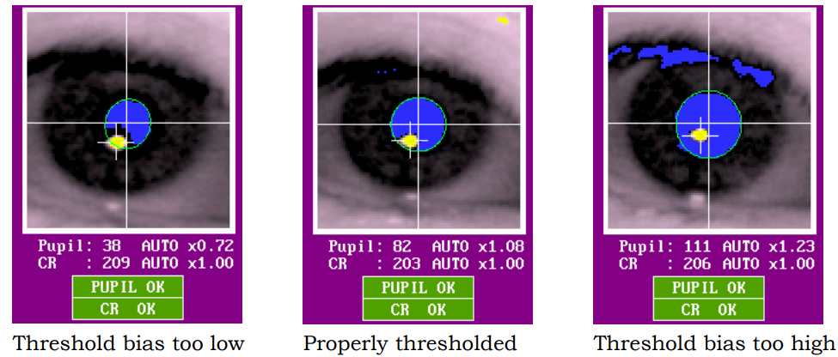up/down arrow in the left top corner next to “pupil”.
   3. If you have a too high/low pupil threshold the calibration will be very messy and not symmetrical.
   4. Sometimes the threshold keeps being stuck on auto, so even though you click to increase/decease it doesn’t actually change the value. Just click again on the eye and this should be solved.
2. **Finding the right corneal threshold**
   1. Once you click on the eye it should calculate the recommended value automatically.
   2. The recommended CR value is between 0.9 and 1.1.
   3. You are aiming to get a solid corneal reflection that isn’t disappearing, but you want to have the threshold high enough that it doesn’t find a fake corneal somewhere because the colors start showing on other parts of the face.
   4. Small steps are good for getting to a precise setting, but to see if it works you might have to jump by steps of 0.10. The recommended CR value is a recommendation, if you are off by a lot but the data looks great check in with someone who know about this, but it might be fine.
   5. Sometimes the threshold keeps being stuck on auto, so even though you click to increase/decease it doesn’t actually change the value. Just click again on the eye and this should be solved.
3. **Good and bad calibration examples**

|  |  |  |  |  |
| --- | --- | --- | --- | --- |
| **Good** | **Bad V1** | **Bad V2** | **Bad V3** | **Bad V4** |
| + + +  + + +  + + + | ++ +  + + +  + + + | +  + +  + + +  + + + | +  + +  + + +  + + + | + +  + + +  + + + |
| Symmetrical | Tell the participant to keep focusing and not try to predict where the next one is | Likely the screen is too high see “setup” | Likely the screen is too high see “setup” | Likely caused by thresholds not being good. See “paragraph 3 and 4 of “Trouble shooting during Calibration” |

1. **The calibration grit result doesn’t seem symmetrical (example Bad V1)**
   1. Make sure the participant is seeing the crosses on the screen.
   2. Make sure the participant is aware, what they should do.
   3. Tell the participant to keep focusing on one cross and only move their eyes once it is accepted by the eye link host pc.
   4. Manually accept the fixation if the eye gaze is at the right place by pressing space bar.
   5. Press Backspace to undo bad calibration points and re-do them.
   6. Re-explain it and let the participant know that you cannot continue without it.
2. **The top left or right X seem off by a fair amount (example Bad V2 & V3)**
   1. The eyes of the participant are not at the same height as the top 25% of the screen. This causes the calibration to miss these marks.
   2. As explained in “Setup” the figure and above “Calibrating steps” shows, you need to make sure the eye line of the participant is on this level. Lower the screen or increase the size of the chinrest to get here while keeping the participant in a comfortable position.
3. **There seems to be a corneal reflection over the participants eye**
   1. If the participant is wearing glasses/lenses this might cause the eye tracker to misread a lot of things. You can change the height of the eyetracker, by putting it on a box/book for example. Because of the different angle the spot might have moved enough. See “General Eye link troubleshooting” for more issues and potential solutions for people with glasses/contacts

## Trouble shooting during experiment

1. **The calibration seemed perfect but the moment the paradigm starts the pupil seems to be wrong or it loses the eye completely.**
   1. Is the background of the paradigm different from the background of the calibration? If so, this might be the problem.
      1. Inform the person who created the paradigm about the issue and tell them to change the background of the calibration if possible (this can be done in presentation).
      2. Change the setting of the Pupil/CR not to be perfect for calibration, but how you think it would work in the paradigm (in the example, you would reduce pupil but not re-calibrate since this would result in a bad calibration. If you run the paradigm it should work better)
2. **The eye tracking seems to be unstable / jittery. When I look at the gaze it seems to never be really stable and/or disappear from time to time.** 
   1. You might have the wrong much pupil threshold. See Calibration trouble shooting for more info on this
3. **The eye tracking has a lot of moment where it does not record the eye.** 
   1. Is the participant blinking a lot? If so, that would be the problem.
   2. Is the target sticker still on the right spot? If not, stick it back on the participant face and re
   3. It might have lost the corneal. Once this happens the pupil (dark blue) also is gone. So when both are lost its often cause by a too high CR threshold. Increasing the threshold decreases the amount of CR you detect in the eye. By decreasing it you might regain the whole eye. For more info see the calibration trouble shooting.

## General Eye link troubleshooting

1. **I started the Host PC without first connecting the eye tracker.** 
   1. You should see an MS-dos like screen. Type “elcl.exe” to run the eye tracking executable file, and only works if it can create a connecting to the eye tracking camera.
2. **I left the camera on after I finished the participant and now it’s burned out.**
   1. Leaving the camera on overnight or over the weekend might cause serious issues. ALWAYS MAKE SURE TO TURN IT OFF. If it’s not working it might not be fixable. Trouble shoot this together with the SR research people from here.
3. **My participant is wearing glasses/lenses what now?**

Both situation can cause a lot of issues. Emphasizing the “CAN” part, because often it will go perfectly smooth. *However, SR-reseach does say that glasses and lenses impact quality of data.*

* 1. The participant’s corneal reflection seems to be all over the eye.
     1. You can change the height of the eyetracker, by putting it on a box/book for example. Because of the different angle the spot might have moved enough.
  2. The pupil seems to be cut in half or disappear all together
     1. Check if the participant is wearing bi-focal glasses, maybe changing the angle as mentioned above might work, maybe there is not possible eye tracking.
  3. The frame of the glasses is picked up as corneal reflection.
     1. This has to do with the color being too dark. There might not be anything to do. The angle of the camera could fix this, but unlikely.

# File Structure and Naming Conventions

This includes formatting conventions to aid in consistency across the lab and ease of future data use and analyses.

* **BDF Files**: ID#_nameparadigm_block#
  + 3019_AVSRT_1
  + 3019_AVSRT_2
  + Even if you plan to do only 1 block, add a number here in case something goes wrong and you end up collecting a separate dataset.
  + **Important:** a new BDF file should be created for each block, or roughly 5-8 minutes of experimenting, to reduce loss in case of server issues or corrupt files.
* **Readme file**: Readme_ID#_paradigmname_date
* **Logfiles** (presentation) Need to be set to not overwrite itself

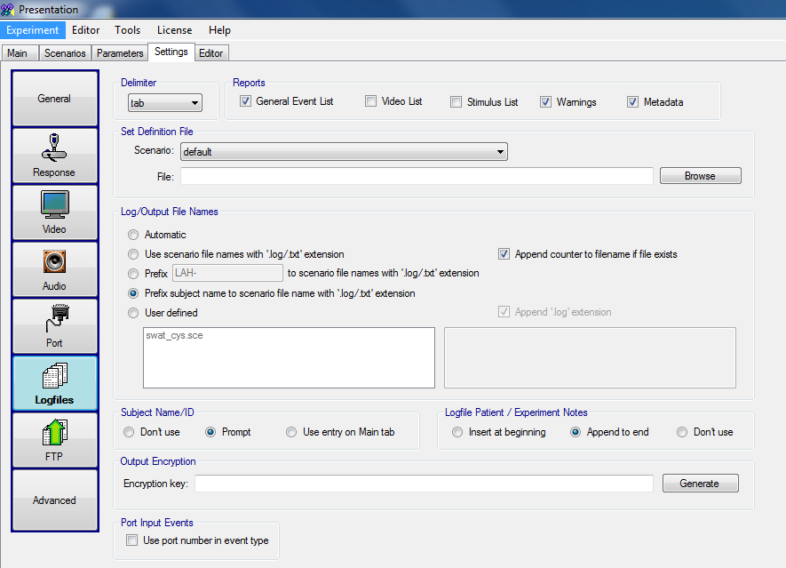

# Hearing and Vision Testing

This outlines the process for hearing and vision testing for participants. Paradigms using either visual or auditory stimuli should be testing and reporting ability for all participants before running their experiment to ensure valid data is being collected.

Hearing test(Based on Beltone model 112)

1. Have participant sit in a place with as little noise possible, such as an EEG booth.
   1. Make sure there is no Pink/White noise in the background.
2. Explain to the participant that they are going to listen to tones
   1. They should indicate every time they hear a sound.
      1. Either by raising hand or pressing response button, depending on setup.
   2. If they hear nothing or stop hearing the tone, they should lower their hand or stop pressing the response button.
3. Place headphones on participant with the red side over their right ear.
4. Set the pitch to 4000 Hz.
5. Set the volume to 40 dB.
6. Determine which ear you are starting on, left or right.
7. Make sure people can’t visually tell when you press the button
   1. Cover the light/screen or have participants face away from screening device.
8. Play the sound for 1-3sec, wait for a reaction.
   1. If the participant responds, turn the volume 10dB lower and play it again.
   2. If they don’t respond, go back up 5dB at a time until you reach a volume they respond to again.
      1. This can sometimes be surprisingly high, don’t be afraid to go above the original threshold they responded to.
9. Write down the score for that frequency in that ear.
10. Repeat the same process for 2000 Hz – 1000 Hz – 500 Hz frequencies.
11. Switch to the other ear and repeat.
12. Pay attention to people that score outside of the +25dB -10dB range
    1. This range is considered normal hearing, check with study lead for exclusion criteria based on hearing ability.
13. Be sure your timing is not too predictable, you want to be sure participants are responding to the actual tones rather than their expectation of a tone.

References:

In person tutorial from Beltone technician

<https://www.cdc.gov/nchs/data/nhanes/nhanes_03_04/au.pdf>

Farsightedness Vision Test(Snellen-chart)

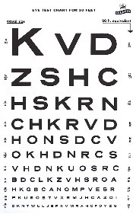

1. Explain the procedure to the participant.
2. Ensure your participant is wearing/not wearing their glasses/contact lenses as they will be during the experiment.
   1. For example, if the EEG is done without glasses the vision test should also be conducted without glasses.
3. Ask the participant to stand on the vision test line marking or at the correct measured distance from the chart.
   1. The chart will state if it is designed for 10 or 20 feet.
4. Ask the participant to cover one eye completely with their hand.
   1. Ensure they aren’t peeking, most common in children but all people are susceptible.
5. Ask the participant read the letters out loud line by line, starting at the top.
   1. As long as the participant reads more than 50% of the line before they make a mistake that line counts and they can continue.
   2. Their score is the marking at the end of the last line they read successfully.
6. Repeat with other eye.
   1. Can take a short break if needed for the closed eye to readjust to the lights.

Meaning of scores:

* 20/20 = normal vision: a person can see at 20ft what an person with normal vision can see at 20 feet
* 20/100: this person can see at 20 feet what a person with normal vision can see at 100 feet.

References:

<https://www.registerednursern.com/visual-acuity-test-snellen-chart/>

<https://www.hves.com/wp-content/uploads/snellen-chart.pdf>

Nearsightedness Vision Test(Snellen-chart) 

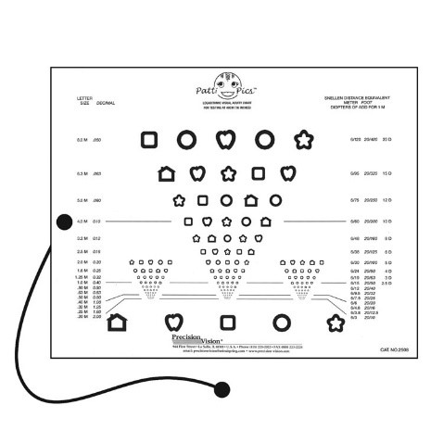

1. Seat participant in well-lit environment and adjust the height of vision chart to approximately eye-level and 40cm from their eyes.
2. Board should initially be on the side that says “MassVAT Logarithmic Visual Acuity Chart”.
3. Give participant the “response board” which contains large versions of all five visual stimuli that are on the vision acuity chart.
4. Instruct participant to use the response board to point to the stimulus they see on the vision chart.
5. Ask participant to cover one eye with their hand to test one eye at a time.
   1. When testing left eye, use the left-side column of stimuli.
   2. When testing right eye, use the right-side column of stimuli.
6. Use the answer key to determine if participant responses are correct.
   1. Note that for any given row if a participant identifies 3 or more stimuli incorrectly (2 or less identified correctly), stop testing for that eye.
   2. Their score is the row above.
      * For example, if a participant identifies only 2 stimuli correctly on the line labeled 20/40, but on the previous line (20/50) identified 3 stimuli correctly, then their vision for that eye should be written as 20/50.
7. Step 4: After testing each eye separately, test vision with both eyes open.
   1. To ensure participants are not memorizing order of stimuli, flip the vision chart over to the side which says “Logarithmic Visual Acuity Chart” and start on row 20/100.
   2. It does not matter if the participant uses the stimuli columns on the left, middle, or right side of the page.
   3. The same scoring and number of correct/incorrect apply when testing both eyes together.

Reference:

<https://www.faa.gov/about/office_org/headquarters_offices/avs/offices/aam/ame/guide/app_process/exam_tech/item51/et/>

# Measuring stimuli sound with audiometer

This outlines the process for measuring the volume in decibels (dB) using a sound meter. This is needed in 2 different scenarios. Scenario 1 – If the paradigm uses speakers, with a volume button. Scenario 2 – if the paradigm uses headphones or anything else that doesn’t have a way to change volume. Volume ALWAYS needs to be controlled by presentation. Presentation settings need to be set so that presentation overwrites the volume always. However if there is a device with an external button, it can still be different per data collection.

For these example we are using Bruel & Kjaer Type 2240 audiometer. The reason for using this is because this was the sound meter that was in the Einstein lab.

## Measuring speaker volume

Because the button on the speakers can be turned by accident we need to test this every time a different dataset is collected. The outcome of the testing highly depends on the booth setup. To prevent any changes due to this, make sure you prepare the booth completely as you would for the participant. This makes sure that if a different person does the testing there are no differences based on that.

Turn on the audio meter (sliding on/off button on the side). Click 2x on the middle button, with the 2 arrows. Like this as soon as you hit play it will register only the loudest sound it hears. You shouldn’t have to press the 3rd button, with the 2 bars, but you can check that the sound meter scale goes from 30 to 110 dB. If it instead says 60 to 140, press it 1x to change it back.

Place the audio meter on the chinrest. Make sure you place it in the same direction, with the upper end of the screen of the audio meter at the edge of the chinrest closest to the screen in the booth.

Start the paradigm, go inside the booth and close the doors. Turn on measuring by pressing the first button, with the play/stop symbols, and wait for a couple of stimuli to pass by. Write down the volume of the stimuli, do this a couple of times to be sure you didn’t register something odd.* If the volume is wrong, decrease/increase using the volume button on the speaker. Measure it all again.

*\*When paradigms have sounds of different volumes this becomes instantly more difficult. If it’s standards and deviants, you only need to measure only the standard. If it’s videos or complex sounds this can be impossible. Talk with a PI to see if you need to do something else.*

## Measure headphones of volume button-less devices

In this case you need to measure the volume before you start the first data collection, so you know you volume. The only thing you can do is measure the headphones sporadically to make sure their quality doesn’t decrease over time. The following picture shows how to do this for in-ear-earplugs.

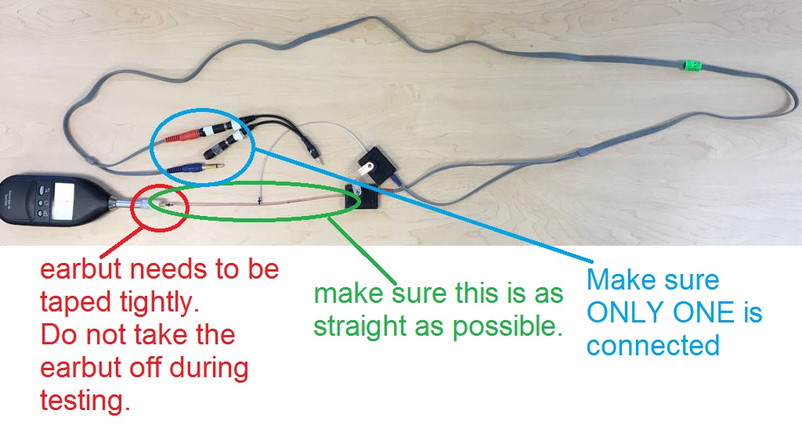

When you would do this for normal earphones, make sure that you take a picture of how you positioned everything so it’s the same between measurements.

# Rochester vs Einstein Protocol Differences

1. **Washing gel syringes does not occur at Einstein, all syringes in this lab are single use only.**